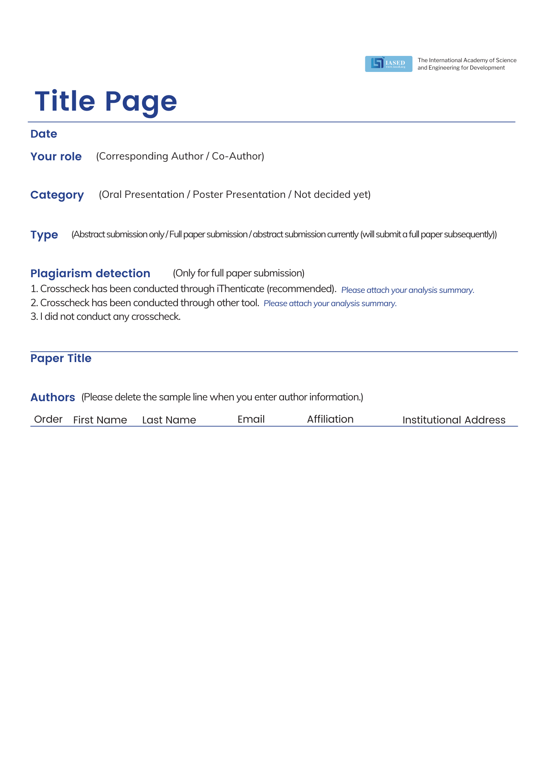

1
2
3
4
5

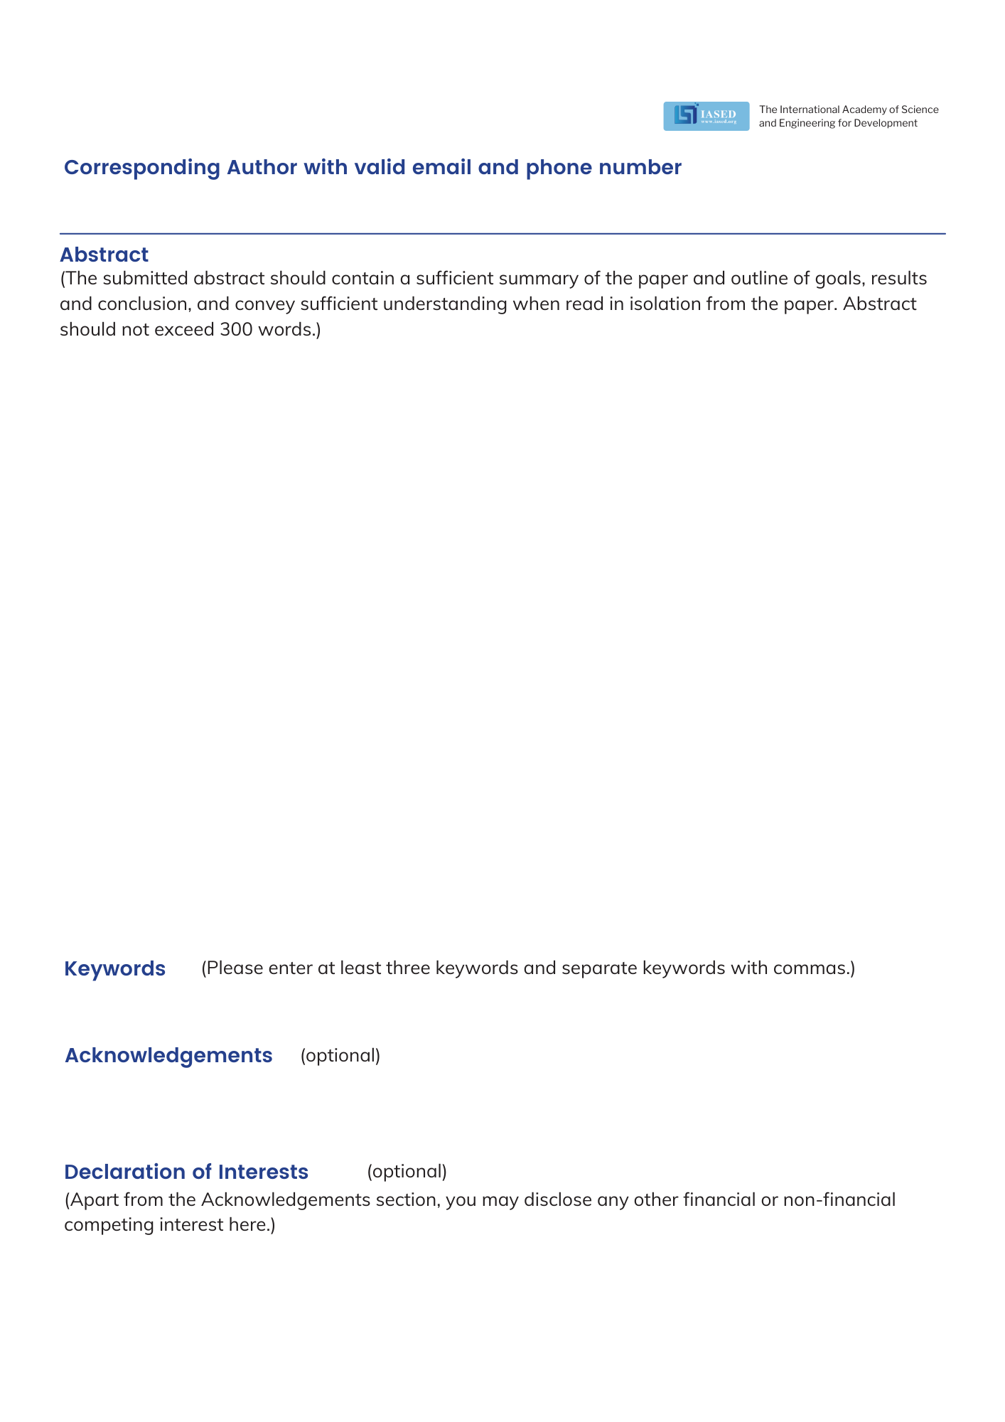

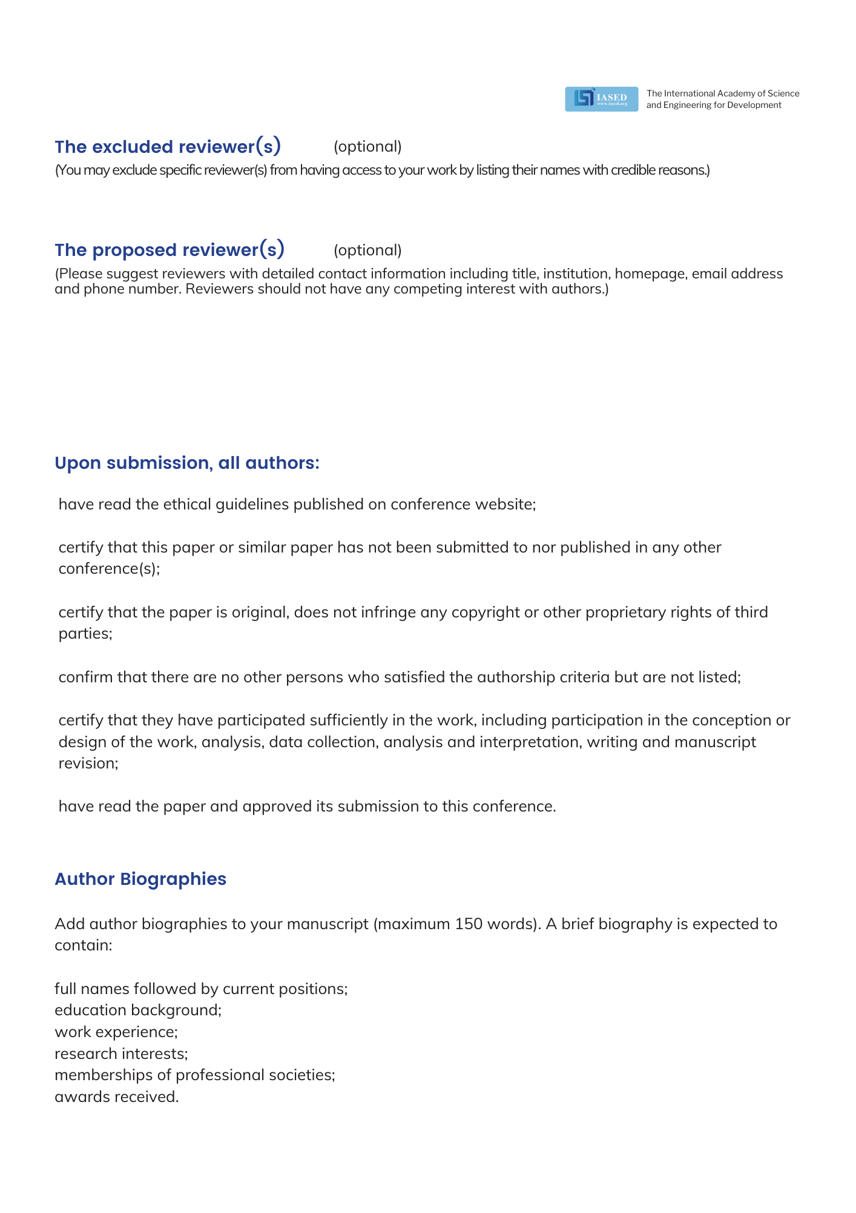



Conference Secretary: Ms. Sukki H.Chiang
Conference Email: contact@iccaee.net
Tel: +852-30696823(English)
Monday-Friday, 9:00am-12:00am and 13:30pm-18:00pm
Full Name | Short Biography (Maximum 150 words)

