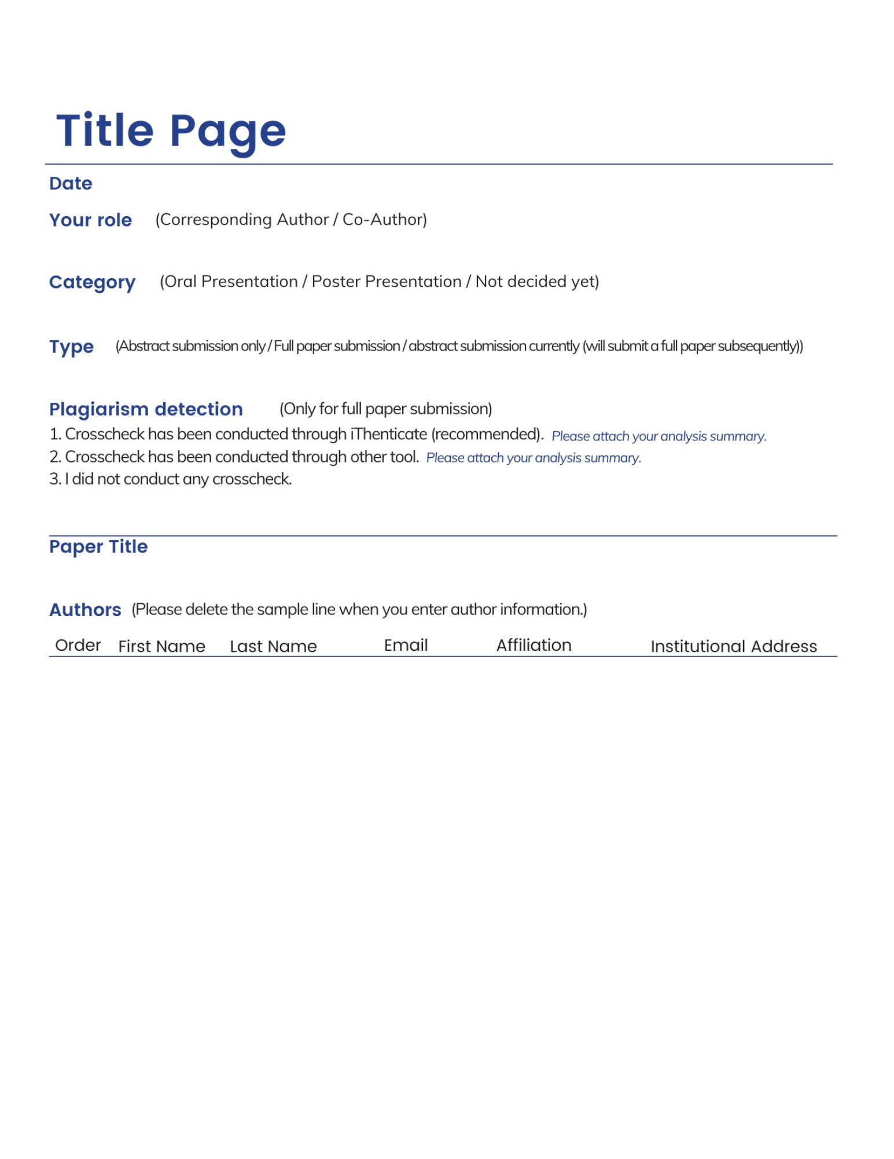

1
2
3
4
5

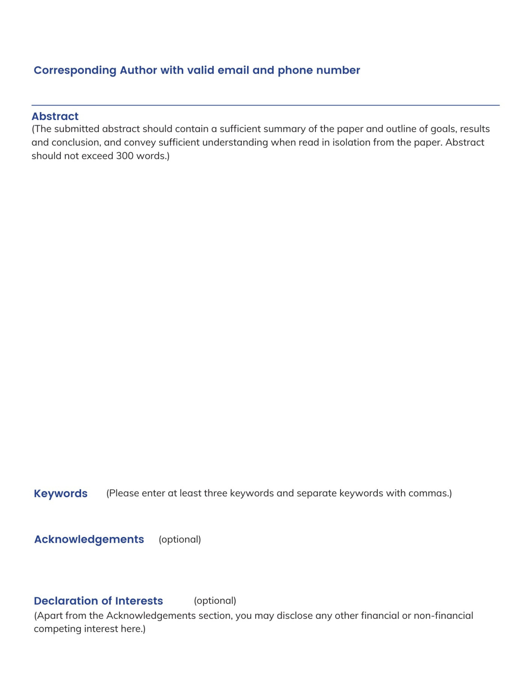

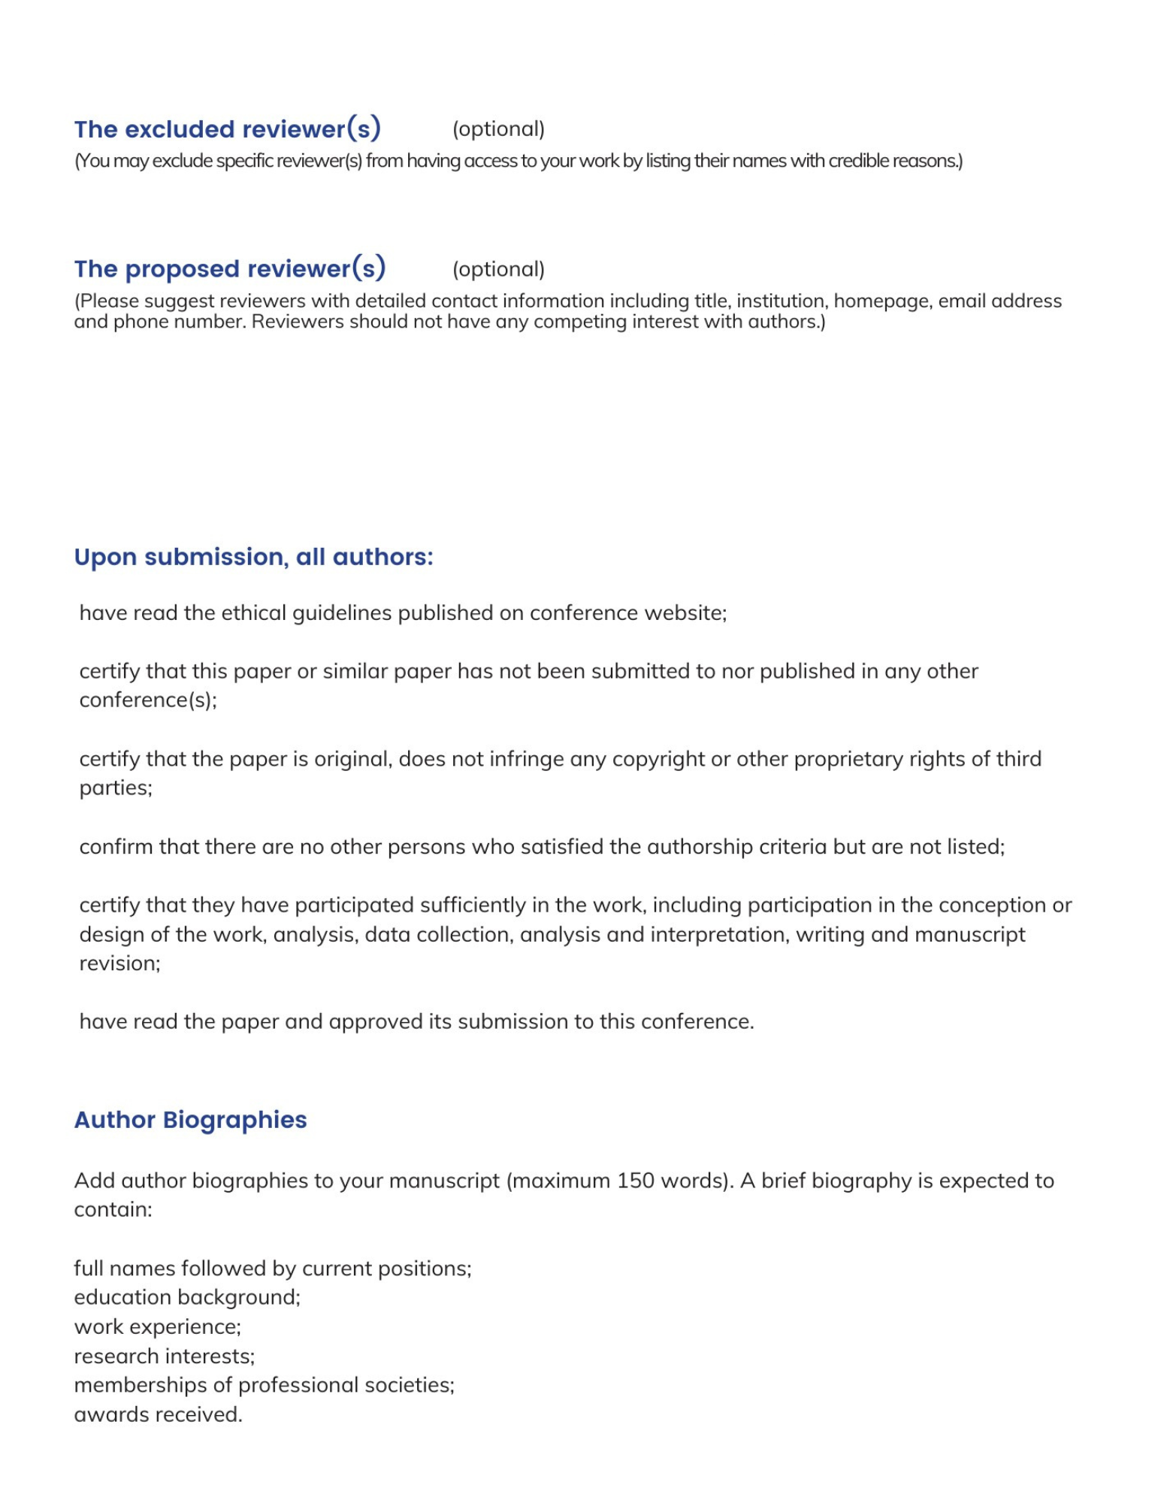

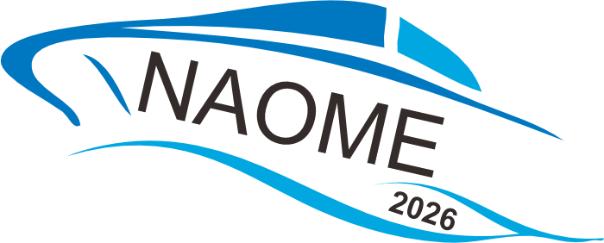

Liam. Liang
Conference Email: email@icnaome.org
Tel: +028-85027305 (Mainland)
+86 28 85027305 (International)
Monday-Friday, 9:00am-12:00am and 13:30pm-18:00pm
Full Name | Short Biography (Maximum 150 words)

